Route 53

So, Route 53 is a managed DNS or Domain Name System.  
And what does the DNS do?

Well, It's a collection of rules and records, which help clients find the right servers through URLs.  
  
***Common records***Mapping www.google.com to an IPv4 address.  
 www.google.com => 12.34.56.78 == **A record**(IPv4 address)

If you are mapping www.google.com to a long IPv6 address, it's called the quadruple A record.  
 www.google.com => 2001:0db8:85a3:0000:0000:8a2e:0370:7334 == **AAAA** IPv6

If you map a host name to another host name,It's called a CNAME because we're  
 search.google.com => www.google.com == **CNAME**

If we are using a mail server to exchange emails then we use **MX records**  
 mail.EXAMPLE.com is the mail server to which it connects

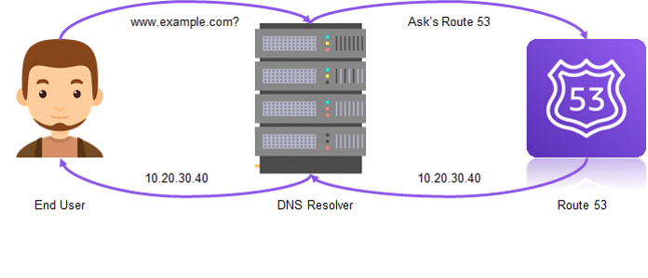

Routing Policies  
  
Simple Routing policy:  
Use for a single resource that performs a given function for your domain, for example, a web server that serves content for the example.com website.  
  
Weighted Routing policy:  
Use to route traffic to multiple resources in proportions that you specify.

Latency Routing policy:  
Use when you have resources in multiple AWS Regions and you want to route traffic to the region that provides the best latency.

Failover routing policy:  
Use when you want to configure active-passive failover

Geolocation routing policy:  
Use when you want to route traffic based on the location of your users.